**The versatile skulls of herbivorous fishes: functional morphology of pacu jaws and teeth**

Emily Poulin

FHL 470: Research in Marine Biology

Spring 2020

Friday Harbor Laboratories, University of Washington, Friday Harbor, WA 98250

Contact Information:

Emily Poulin

Department of Biology

University of Washington

Seattle, WA, 98105

empoulin@uw.edu

Keywords: evolutionary ecology, frugivory, linear morphometrics, phytophagy, Serrasalmidae

**Title**

The versatile skulls of herbivorous fishes: functional morphology of pacu jaws and teeth

Emily Poulin, Marine Biology & Physiology 2021, University of Washington

**Abstract**

The Serrasalmidae are a family of freshwater Neotropical fishes that includes carnivorous piranhas as well as their herbivorous relatives, the pacus. Pacu diets consist of leaves, stems, fruits, seeds, and algae, as well as insects, benthic invertebrates, plankton, and smaller fish if available. These diverse prey materials appear concomitant with diverse jaws and dentitions, suggesting that some species are ecomorphologically specialized for feeding on certain prey. We investigated how the pattern and tempo of feeding morphological specialization in pacus reflects the ecological diversity of their food resources. Pacu species were first categorized as either algivores, frugivores, folivores, phytophages, planktivores, or omnivores based on a meta-analysis of published gut content data. We then used CT scanning and linear morphometrics to describe the primary morphological axes of jaw and dental variation, and any correlates these phenotypes may have with each species’ primary prey. We found significant differences in the occlusional offset, opening mechanical advantage, jaw width, and sagittal crest height between the different diet guilds. The phytophages tended to have lower occlusional offsets, and showed higher resemblance to piranhas than other pacus with scissor-like occlusion. Additionally, we found significant differences in the rates of morphological disparity through time among the different diet groups. Folivores had morphological rates of evolution over 40 times faster than that of planktivores, suggesting different selective regimes acting on each group in association with diet. These findings indicate that because different species of pacu have different diets, we cannot expect their dentitions to look and function in the same ways.

**Keywords:** evolutionary ecology, frugivory, linear morphometrics, phytophagy, Serrasalmidae

**Introduction**

Vertebrates play a crucial role in maintaining biodiversity of the Amazon rainforest by digesting and dispersing seeds, and there is a strong interconnectedness between the diets of these seed dispersers and the plant composition of the rainforest (Correa, 2007). Previous studies have analyzed the connections between the diets of mammals, birds, and primates with patterns of seed dispersal, yet herbivorous fishes play a critical role in maintaining biodiversity in the Neotropical forests and have often been overlooked (Anderson, 2009; Correa, 2007). Pacus are an herbivorous group of Neotropical fishes from the family Serrasalmidae, and they consume a wide variety of plant material including fruits, nuts, seeds, leaves, stems, shoots, and algae (Correa & Anderson, 2016). Although generally herbivorous, the dentitions and skull structure among pacus differs depends on which plants (or parts of plants) these fishes specialize on. Previous evidence has indicated connections between the functional morphology of serrasalmid dentitions and diets based on the increased efficiency of certain morphologies for specializing on particular prey sources (Correa & Winemiller, 2014; Huie et al., 2019). Pacus therefore are an ideal study system for examining the ecomorphological correlates between plant prey materials and the structures (jaws & teeth) used to process them.

Frugivory is one commonly observed feeding strategy in pacus and helps to minimize dietary overlap between fish who live in the same territories (Correa & Winemiller, 2014). Similar strategies of niche partitioning are also found in terrestrial vertebrate herbivores, and are reminiscent of competitive avoidance. For instance, volant, terrestrial frugivorous bats (Microchiroptera) tend to have palates that are greater in width than length, and have high tooth area closer to the anterior end of the dentition for grasping fruit (Freeman 1988). These adaptations allow for frugivorous bats to feed on fruit more efficiently compared to bats who have adapted to feed on other prey sources, leading to less niche overlap between highly specialized frugivores and other diet guilds. In contrast, it was observed in browsing and grazing ungulates that the tooth area is higher at the posterior end of the tooth row in order to have a higher mechanical advantage for grinding tough plant material (Pérez–Barbería & Gordon, 2001); these morphological adaptations will also help to minimize niche overlap between browsing and grazing ungulates and more generalized herbivores. Based on these findings, we expect to see relatively greater jaw widths and lower mechanical advantage in the frugivores compared to other diet guilds because these morphological specializations would be evolutionary favorable as they lead to less niche overlap between different pacu diet guilds when food resources are scarce (Andrade et al. 2019b, Correa & Winemiller, 2014).

Another notable example of diet specialization associated with novel dentary and cranial adaptations is phytophagy. Phytophages primarily consume Podostemaceae, which is an aquatic angiosperm that grows in rocky rapids with high flow rates (Philbrick and Retana, 1998; Huie et al., 2019) (Figure 1). In Huie et al. (2019), geometric morphometric data revealed that phytophagy corresponded with an elongated, highly streamlined body (Huie et al., 2019). It also proposed that phytophagous fishes who inhabit rheophilic habitats face strong selective pressures to adapt morphologies that increase swimming efficiency when residing in rapids, such as a reduced swim bladder, which, in addition to the elongated body shape, lowers buoyancy and drag, as well as reduces energy expenditure (Andrade et al. 2019b, Conway et al., 2012; Birindelli & Britski, 2013). Considering these findings, we predict that the phytophages will show morphological differences with respect to jaw and cranial morphology due to the strong selective pressures in these rapids habitats.

Due to the differences in physical properties and habitats that various pacu prey species occupy, we do not expect the dentitions of all pacus to look and function in the same ways. Our objectives for this study were (1) to better understand how pacu lower jaw morphology varies among diet guilds and whether there are specific functional correlates associated with distinctive prey, (2) to examine how patterns in functional trait evolution reflects the ecological diversity in pacu, and (3) to see how disparity through time fluctuates as new niches became exploited by pacus.

**Materials & Methods**

***Specimen acquisition and MicroCT scanning***

For this project, 40 species of pacus were examined from 11 genera, for a total of 56 museum specimens (Table 1). Where possible, we used adult and subadult specimens to avoid the confounds of ontogenetic changes in diet and morphology. We visualized specimen skeletons using the Bruker Skyscan 1173 micro-computed tomography (µCT) scanner, (Bruker Corp. Billerica, MA) at Friday Harbor Lab’s Karel Liem Bio-Imaging facility. Specimens were marked with a radio-opaque label, tightly wrapped in ethanol-moistened cheesecloth (to prevent desiccation), and then placed in a 3D-printed polyvinyl alcohol (PVA) plastic cylinder sealed with plastic wrap. Scans ranged from 55-70 kV and 100-145 μA, while the voxel size ranged from 17.1-68.2 μm. The scans were then reconstructed as .bmp image stacks and the skulls were isolated using DataViewer software (2012–15 Bruker microCT,Dataviewer Version 1.5.24, 64‐bit). Next, DicomConverter software (2007–17 Bruker microCT, DicomCT, Version 2.5) was used to convert the files to. dcm format. The .dcm files were converted to .nrrd files with ImageJ/FIJI (year, version info; Schneider et al., 2012) following the technique of Buser et al. (2020).

***Functional Jaw Morphometrics***

We used 3D Slicer’s (v. 4.10.1, https://www.slicer.org/) ruler and fiducial tools to collect linear morphometric data on the functional aspects of jaws, teeth, and cranial skeleton (Buser et al., 2020). These morphometrics, described below, have been established by prior literature as functional proxies for aspects of feeding like bite forces, suction feeding, and tooth performance (Figure 2) (Anderson, 2009; Arbour & Lopez-Fernandez, 2013; Huie et al., 2019). In 3D Slicer, we measured the opening and closing in-levers and out-levers for the jaw apparatus, which are used to calculate mechanical advantage. Mechanical advantage describes jaw leverage relative to the animal’s jaw joint, with the opening in-lever defined as the distance from the sternohyoideus insertion on the lower jaw’s articular process (Westneat, 2004). The closing in-lever was measured from the insertion of the jaw adductor musculature on the lower jaw to the jaw joint. The anterior out-lever was the distance between the jaw joint and the base of the second anterior tooth, while the posterior out-lever was the distance between the jaw joint and the base of the most posterior-most tooth.

Serrasalmids vary with respect to their jaw occlusion, with jaws that behave either like a pair of shears or scissors *vs*. those species in which the dentition come together like a vice or pliers. To capture these differences, we measured occlusional (quadrate) offset (Anderson, 2009; Arbour & Lopez-Fernandez, 2013): the distance between the jaw joint relative to a line perpendicular to the plane of the dentition (Figure 2). We also calculated the shearing quotient, which is the ratio of the length of the cutting surface of the teeth *vs*. the length of the teeth. A higher shearing quotient indicates that the species is able to cut through tough material, while a species with a lower shearing quotient is better suited for crushing softer foods (Kay & Covert, 1984). To visualize teeth, which were often obstructed by their adjacent dentition, specimens’ lower jaws were segmented and then volume rendered using 3D Slicer’s Volume Render module and anterior and lateral sides of the jaws were imaged. These images were loaded into ImageJ/FIJI, and then tooth row length and each tooth’s cusp length were measured, which were used to calculate the dentition’s overall shearing quotient (Kay & Covert, 1984). Measurements were taken from the teeth on the left side of the jaw when possible for consistency. Tooth sharpness was calculated using the angle measurement tool in ImageJ/FIJI, and a lower included angle indicates a more sharply-pointed tooth which is well suited for piercing tough prey such as insects, leaves, and stems (Freeman 1988; Crofts et al., 2019).

Jaw length and width were calculated using the fiducial tool; jaw length was the dentary length, and jaw width was the lateral distance between the left and right mandibular bodies. We also used 3D Slicer’s screenshot tool, we imaged the sagittal crest in lateral view and measured the height and area of this structure in FIJI. Finally, we measured each specimen’s head length, head height, and head width for size correction (see below).

***Diet Meta-Analysis & Categorization***

We conducted a meta-analysis of published gut content data for pacus, in order to categorize species into separate dietary categories (Table 1). In cases where multiple records exist for a given species, only volumetric or composite metric (e.g. IRI, Index of Relative Importance) data were retained for our analyses. However, non-volumetric data was used if it was the only available diet data for a species (5/40 species). If multiple volumetric datasets existed for a given species, these data were averaged together before further analysis. For several species, no quantifiable diet data were available; in these situations, qualitative data was used to categorize the diet instead (9/40 species) and we assumed equal importance of reported prey items. Additionally, the diet of *Utiaritichthys longidorsalis* is currently unknown (except for the fact that it eats Podostemaceae; Jegu et al., 1989; Pereira & Castro, 2014), so we averaged the diet of its two congenerics (*U. esguiceroi & U sennaebragai*) together as a substitute. Since pacu diet resources are diverse, we used heirarchical cluster analysis to reduce dimensionality by grouping pacus with similar or overlapping diets together. We generated a Euclidean distance matrix using the function *pvclust* (Suzuki et al., 2006) and assumed a 60% dissimilarity threshold to distinguish between six significant diet categories (Egan et al., 2018).

***Statistical Analyses***

*Morphology-Diet relationships*

Data were size-corrected by dividing all trait variables (excluding mechanical advantage, shearing quotient, and tooth aspect ratio, which are dimensionless and therefore already corrected for size) by the geometric mean of the specimens’ head length, head width, and head height. In-lever and out-lever lengths were measured to calculate mechanical advantage, but they were not included in later analyses. These size-corrected trait variables were averaged across multiple individuals for phylogenetic analyses.

In order to investigate relationships between feeding traits and diets, we conducted two tests of analysis of variance (ANOVA) using the R statistical coding language (www.rproject.org). We used the R function *aov* to test for correlations between diet and our functional morphometrics for our full dataset (n=40 species). Our project also aimed to examine the serrasalmid phylogeny to find patterns in the correlations between dietary preference and dentary morphology. To do this, we used the Kolmann et al. phylogeny (*in review*), and trimmed it so that only the pacu species that were previously measured were included in the analysis. This dataset, along with the diet and morphological trait data, were used to generate phylogenetically-explicit ANOVAs with the *phylANOVA* function (phytools package; Revell, 2012).

We used the *princomp* and *phyl.pca* functions to construct morphospaces and describe the major morphological axes of variation in pacus, while reducing the dimensionality of our dataset (Revell, 2012). We used the broken-stick test to test for significant axes and retained the first three PC axes for our analyses.

We predicted that species in each of the diet categories would take up non-overlapping regions of the morphospace. We used the *phylomorphospace* function (Revell, 2012) to examine if there were significant differences in the regions occupied by each diet group in the morphospace. We then reconstructed the morphological disparity through time between the pacus to examine the possible transition rates between the various diet groups in the morphospace. To do this, we examined the PC1 and PC2 axes and plotted how these trait variables have changed through time using the *ape* package in R (Paradis 2019).

*Evolutionary morphology*

We used stochastic character mapping (Bollback, 2006) to simulate the evolution of pacu diet states across the Kolmann et al. (in review) phylogeny, with the *make.simmap* function (phytools package). We used this method of ancestral state reconstruction to evaluate how many times any given diet state had evolved and whether some diet states were specific to certain clades and not others. We evaluated the fit of three different transition models, the equal-rates model (ER), symmetrical rates model (SYM), and all-rates-different model (ARD), by comparing the log likelihood and AICc scores among models. Due to the number of diet states relative to the number of species in our tree, we examined diet evolution across the entire serrasalmid phylogeny to increase our statistical power. This involved adding two additional diet states specific to piranhas, ectoparasitism (fin- and scale-feeding) and piscivory, to these ancestral state reconstructions.

We were also interested in changes in tempo and mode of morphological diversification in pacus throughout time. To quantify and visualize patterns of morphological diversification, we calculated changes in the morphological disparity index (MDI) through time using disparity-through-time (DTT) plots (Harmon et al., 2003). These methods plot the observed MDI through time and compares it against a Brownian motion expectation. Finally, we were interested in contrasting rates of multivariate morphological evolution among pacu species in different diet guilds. We used the *compare.evol.rates* function (geomorph; Adams & Collyer, 2018) to track changes in all of our morphometric traits at once and test for differences in these rates among diet guilds.

**Results**

***Diet niche estimation and ancestral state reconstruction:***

How many different diet niches are present among pacus and how many times have these niches evolved? Cluster analyses returned six diet guilds within pacus, according to the 60% dissimilarity threshold: frugivores, algivores, phytophages, folivores, planktivores, and omnivores (for piranhas: ectoparasites, piscivores, and omnivores). Stochastic character mapping (Figure 3) revealed that ancestral serrasalmids mostly likely were omnivores, although uncertainty at these early nodes limits our confidence (Figure 3). From these earliest omnivorous or generally herbivorous ancestors (Correa et al., 2007), pacus have radiated to become frugivores, algivores, phytophages, folivores, planktivores; however, as each lineage group has omnivorous origins, perhaps unsurprisingly omnivory was the most prevalent diet mode across the family (Figure 3). Most diet guilds tended to be clade- or lineage-specific, e.g. planktivory and algivory are unique to *Metynnis* and the radiation of *Metynnis* and myleines can partially explain the large upturn in morphological disparity of the group ~20 MYA (see below, Figure 5: DTT plot).

Similarly, those phytophagous pacus feeding to varying extents on Podostemaceae (rheophilic riverweed plants), have evolved at least four times; once each in *Utiaritichthys, Acnodon oligacanthus, Ossubtus xinguense,* and again in the ancestor of *Tometes+Mylesinus+Myleus*, contrary to what was previously proposed about the group (Huie et al. 2019). Frugivory has evolved independently three to four times in pacus. However, we were not able to include *Pristobrycon maculipinnis* in our phylogeny; this species is a documented seed & fruit predator thought to be closely related to other omnivorous piranhas like *Pygopristis* or *Pristobrycon striolatus*, which would increase the number of independent evolutionary occurrences of frugivory/granivory across serrasalmids (Goulding, 1980; Fink & Machado-Allison 1992).

***Morphometrics & ecological correlates:***

The phylogenetic ANOVA revealed that there was significant variation between the dentary morphology of the different diet groups. Specifically, open MA (F=2.396, *p*=0.0414), jaw width (F=2.751, *p*=0.022), sagittal crest height (F=2.896, *p*=0.017), and occlusional offset (F=0.00153, *p*=0.00153) varied in association with diet (Table 2). The phytophages had significantly higher opening mechanical advantage (MA) compared to omnivores (*t*=2.753, *p*=0.010), which allows for a faster, more forceful bite; the omnivores have evolved to have faster jaw opening than the phytophages. We found a significant difference in the jaw width between the folivores and algivores (*t*=1.906, *p*=0.059), with the folivores tended to have wider jaws that the algivores. Sagittal crest height showed significant differences between phytophages and algivores (*t*=2.457, *p*=0.020), and phytophages and the unknown diet group (*t*=?, *p*=0.039). When comparing phytophages to algivores, we noticed that algivores tended to have higher size-correlated crest heights, while crest height was highly variable in phytophages (mean = 12.23 mm, S.D. = 4.82 mm in algivores; mean = 13.37mm, S.D.= 10.67mm in phytophages). Occlusional offset differed between phytophages and algivores (*t*=2.528, *p*=0.002), folivores (*t*=1.753, *p*=0.076), frugivores (*t*=2.257, *p*=0.007), and omnivores (t=2.409, p=0.005). Phytophages differed from all other groups because they tend to have a much lower occlusional offset, i.e. scissor-like jaws reminiscent of piranhas more so than other pacus. The ANOVA confirmed that anterior MA (F=0.36, *p*= 0.901), posterior MA (F=0.372, *p*=0.893), jaw length (F=0.819, *p*=0.56), shear quotient (F=1.279, *p*=0.284), included angle (F=1.369, *p*=0.246), or tooth aspect ratio (F=1.51, *p*=0.195) did not differ significantly between the diet groups. When the phylogeny was taken into account, there were no significant differences found between the diet groups (Table 2).

***Evolutionary axes of morphological variation, tempo, & mode:***

We used a phylomorphospace approach to explore the major morphological axes of the feeding mechanism in pacus. The phylomorphospace showed a high amount of trait overlap among pacu taxa (Figure 4). Omnivores, planktivores, and frugivores tended to score high on both PC1 and PC2, indicating correlation with higher values for opening MA, sagittal crest height, and occlusional offset. Conversely, phytophages tended to score the lowest on both PC1 and PC2, which indicates lower opening MA, sagittal crest height, and occlusional offset. Whereas the phylomorphospace reveals high amounts of overlap among pacus, phytophages consistently occupied the distal margins of the phylomorphospace, e.g. *Tometes trilobatus* and *Tometes ancylorhynchus* both had lower PC2 scores than pacus in any of the other diet guilds. Additionally, when looking at some of the sister taxa, there are large distinctions between them; for instance, *Tometes* species all tend to look different from one another, and they take up a wide range on the morphospace. *Mylesinus paucisquamatus* was near *Tometes trilobatus* in the morphospace even though the components of their diets differ substantially between folivory *vs*. phytophagy, respectively. The wide range of PC scores observed in the pacus, specifically *Tometes*, points to the conclusion that many different morphological configurations are sufficient for consuming similar resources.

Overlap or adjacency among taxa in phylomorphospace supports instances of convergence and parallelism in the feeding mechanisms of pacus. Parallelism is suggested between the frugivores *Piaractus* and *Colossoma*, which are close relatives, as well as convergence between these species and *Myloplus planquettei*, another frugivore (Figure 4). Another instance of convergence is among the phytophages *Tometes trilobatus, Tometes ancylorhynchus,* and *Ossubtus xinguense*. The traits of these phytophages are similar to other grazers, specifically the folivores. For instance, *Mylesinus paucisquamatus* occupies a similar region of the morphospace as *Tometes trilobatus and Ossubtus xinguense*, even though they are in different diet guilds; this could be because *Mylesinus paucisquamatus* feeds on both Podostemaceae and foliage, so it is partially rheophillic and therefore shared morphological traits with the phytophages.

Finally, our DTT plot reveals a positive trend in morphological disparity for pacus through time, but no significant difference from the Brownian expectation (MDI = 0.355; p = 0.98) (Figure 5). As previously mentioned, there was a large upturn in morphological disparity around 23-20 MYA, which corresponds well with the radiation of myleines and *Metynnis*. Up until this point in time, pacus were reconstructed as generally omnivorous (see Fig 3-SIMMAP), with myleines evolving into folivorous and phytophagous niches and *Metynnis* exploiting plankton and algae as novel prey resources. We also observed significant differences in the rates of phenotypic evolution among the different diet guilds. The rate of folivore phenotypic evolution was 43 times greater than the rates observed in the planktivores (2.594 *vs*. 0.067). In general, the rate of phenotypic evolution in planktivores differed significantly from the rate observed in every other diet guild, being much lower. Additionally, the rate of evolution in folivores (2.594) was nearly twice as fast as the rates seen in omnivores and phytophages (1.417, and 1.406, respectively). Folivores also differed significantly from algivores, evolving much faster (2.594 *vs*. 1.250).

**Discussion**

Pacu consume a wide variety of plant materials that vary in size, toughness, and location where it is found (Correa & Anderson 2016, Correa & Winemiller, 2014). These differences in prey characteristics lead to the expectation that there would be high morphological disparity in the lower jaw and cranial skeleton among species in different diet guilds (Huby et al., 2019). Our results revealed that there were significant differences in jaw and cranial morphology among the some of the diet guilds; however, our analysis also revealed a tight correlation between the serrasalmid phylogeny and diet, which caused our results to lose statistical significance when the phylogeny was incorporated into the analysis. This occurred because as species are more closely related to each other, we expect them to look and function more similarly than they would to more distant relatives (Sidlauskas, 2008). Although our results did not show significant differences phylogenetically, there is still variation in the jaw and cranial skeleton that is correlated with the different diet niches that reveals morphological specializations associated with diet. Therefore, pacus in the same clade tend to look similar to each other, but dissimilar to those in clades with different dietary niches.

*Functional novelties in the feeding mechanisms of phytophagous pacus*

When we look at differences between the diet guilds without taking the phylogeny into account, we can see significant differences in the occlusional offset, opening mechanical advantage, and sagittal crest height between the phytophages and the other diet niches. Jaw occlusion varies from behaving like a pair of scissors to a pair of pliers. Scissor-like jaws have lower occlusional offset measurements, and have adapted to slice through prey, while the fish with plier-like occlusion are better adapted for crushing (Anderson, 2009; Arbour & Lopez-Fernandez, 2013). The phytophagous pacus had significantly lower occlusional offsets than the algivores, folivores, frugivores, and omnivores (Figure 6B) which indicates that the occlusion in the phytophages is serving a different function than it is for herbivores pacus. Interestingly, the occlusional offset seen in phytophages was more similar to piscivorous piranhas than other herbivorous pacus (Figure 7) (Kolmann et al. 2018a). The piranhas feed on other fish, and their low occlusional offsets allow them to easily cut through flesh (Huby et al., 2019). Phytophages nip or scrape encrusting Podostemaceae off of rocks in rapids and they appear to benefit from also having a scissor-like occlusion for slicing, as opposed to the crushing morphology observed in other herbivorous diets (Andrade et al. 2019b, Huie et al. 2019).

The frugivores had consistently greater occlusional offsets compared to the other dietary niches. Additionally, frugivores also had greater jaw widths compared to the other diet niches, which is consistent with dentary characteristics in Microchiropterans (Freeman et al., 1988) (Figure 8). This is an interesting instance of convergence between two unrelated frugivores, and suggests that increased jaw width is associated with feeding on fruits and seeds. Perhaps broader jaws are beneficial for frugivory because it increases palette area and allows for larger, stiffer fruits to be crushed; additionally, if more pressure is generated, more of the juices and nutrients can be extracted from the fruits (Freeman et al. 1988, Correa et al. 2007).

*The evolution of diet and ecological diversity in herbivorous pacus*

The ancestral state reconstruction of the serrasalmid phylogeny provided insight on the evolutionary history of the group with respect to dietary niches (Figure 3). Omnivory was the ancestral state for early serrasalmids. Phytophages, which have shown novel morphologies compared to the other dietary guilds have independently evolved four times and frugivory has also evolved at least four times. Both of these dietary niches have strong constraints relating to habitat and prey characteristics compared to those associated with more generalized diets (Andrade et al. 2019b, Correa & Winemiller, 2014). The multiple evolutionary instances of these dietary guilds indicates the strength of the selective pressure guiding towards dentary adaptations found in phytophages and frugivores (Correa et al. 2007, Andrade et al. 2019b).

The phylogeny (Figure 3) provides insights into the evolutionary relationships between the species plotted in the morphospace (Figure 4). The closer two species are in the morphospace, this may indicate some degree of functional convergence or parallelism (Sidlauskas 2008). We found potential evidence for parallelism between the frugivores *Piaractus orinoquensis* and *Colossoma macropomum*, and convergence among the phytophages *Tometes* *trilobatus, Tometes ancylorhynchus,* and *Ossubtus xinguese*. These findings, when considered with the multiple instances of independent evolution of phytophagy and frugivory we observed in Figure 3, reveals how the selective pressures associated with these diets select for individuals with highly specific morphologies.

*Patterns of ecomorphological variation through time in pacus*

The disparity through time plot (Figure 5) shows a positive increase in pacu jaw disparity, albeit not significant when compared to the simulated mean disparity. There is a steep upturn in observed morphological disparity around 20-25 MYA, which corresponds to the radiation of myleines and *Metynnis*. The radiation of these clades may have had such drastic effects on the observed morphological disparity of the pacus because of their associated disparity in diet: the myleines are predominantly folivorous and *Metynnis* species are primarily algivores and planktivores (Figure 3). These new diets (relative to their frugivorous ancestors) were evolutionary novelties for the serrasalmid family, and the increased reliance on novel diets presumably has led to increased morphological diversification for feeding on these new prey resources.

Although these new diets drastically increased the morphological diversity of the serrasalmid family, transitions to planktivory or algivory occurred the least frequently out of transitions between other diet guilds. In other words, once a species becomes planktivorous or algivorous there is a lower likelihood that they will leave either of these niches. This low likelihood of changing to or from an algivorous or planktivorous niche suggests strong constraints on deviations from certain phenotypes or ecologies, specifically for planktivores. For example, rates of morphological evolution (Table 3) vary greatly between planktivores and frugivores, with planktivore feeding anatomies evolving approximately 40 times slower than that frugivores and significantly slower than all of the other diet niches. Perhaps the planktivore feeding anatomy evolved much slower than frugivores because planktivores have less evolutionary pressure on their jaw and teeth morphology; instead of primarily biting to capture food, they rely on specialized gill structures called gill rakers (Storm et al. 2020). Our study did not accurately assess other traits that would reveal further morphological differences between the planktivores and other dietary niches, but we believe that collecting morphometrics to categorize diversity of the gill rakers could be more representative of the selective pressures faced by planktivores (Storm et al. 2020).

Further analysis of planktivore gill morphology could provide insights to the novel morphological adaptations of this dietary guild. Collecting morphometric measurements of terrestrial herbivores, specifically frugivores and folivores, could serve as interesting comparisons to the dentary morphology of pacus who are in the same dietary niches. Additionally, in this experiment the lower jaw morphology was measured but examining the characteristics of the upper jaw could further reveal differences between the different diet guilds. The ways that the upper jaws occlude with the lower jaws of serrasalmids determines if the bite is scissor-like or vice-like, and a better understanding of the variation in upper jaw morphology among the diet guilds could reveal differences that were not detectable from measuring lower jaw morphology alone (Huby et al., 2019). Some of the largest pacu species (*Piaractus, Colossoma, Myloplus rhomboidalis,* and *Myloplus asterias*) have a dental hiatus or diastema between the labial and lingual tooth rows in the upper jaw. The morphology of the teeth on either (anterior or posterior) side of the diastema are quite different, similar hiatus in between dental batteries in animals like horses, is meant to act as an exclusion zone for non-edible particulates like grit that might damage the posterior dentition. More insight into the occlusional architecture of pacus is on-going.

**Acknowledgements**

We thank M. Dethier and A. Ames for organizing remote research at Friday Harbor Labs. We thank A. Summers, K. Cohen, J. Huie, and M. Gerringer (UW-FHL) for help with CT scanning. We thank museum staff M. Sabaj, M. Arce (ANSP); J. Armbruster, D. Werneke, M. Hayes (AUM); C. McMahan (FMNH); D. Catania (CAS); M. Burridge, M. Zur, E. Holm, D. Stacey (ROM); H. Lopez-Fernandez, K. Alofs, R. Singer, R. Nagesan (UMMZ); J. Egan (WMU), T. Buser (OSU); R. Peterson, L. Hughes, and G. Orti, P Hernandez (GWU) for help with specimen acquisition. MAK received support from the NSF-DBI 1712015 Post-Doctoral Research Fellowship in Biology.

**Figures & Tables**

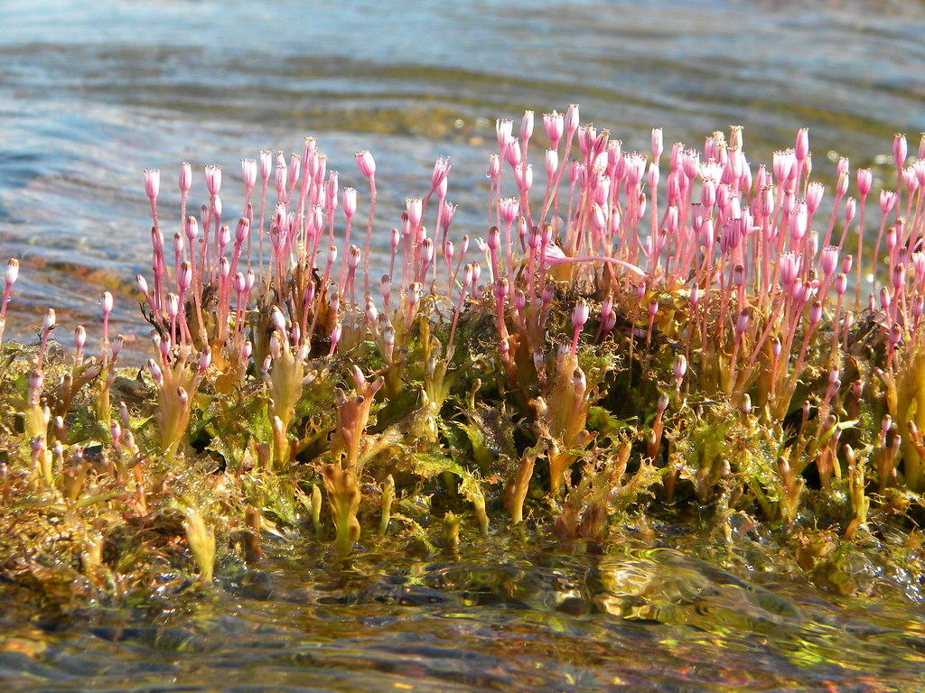

**Figure 1:** Podostemaceae, a rheophilic riverweed plant, (left) is the primary food source for phytophagous pacus in the Amazon River Basin (Koch 2012). Podostemaceae grows near rapids in areas with high flow rates (right) (Walker 2016).

**Image citations**

Koch, A. (2012, August 7). *Rhyncholacis* sp. (Podostemaceae) [Digital image]. Retrieved June

 08, 2020, from https://www.flickr.com/photos/anakbot/7732602628

Walker, R. (2016, September 6). To Keep a River Running. Retrieved June 08, 2020, from

https://www.earthisland.org/journal/index.php/magazine/entry/to_keep_a_river_running/

**Table 1:** List of species examined along with their museum & catalogue number, and diet. Diets were determined through a literature review based on available data from previous publications. The abbreviations used for diet group are as follows: Om = omnivore, Ph = phytophage, Fr = frugivore, Pl = planktivore, Fo = folivore, and Al = algivore.

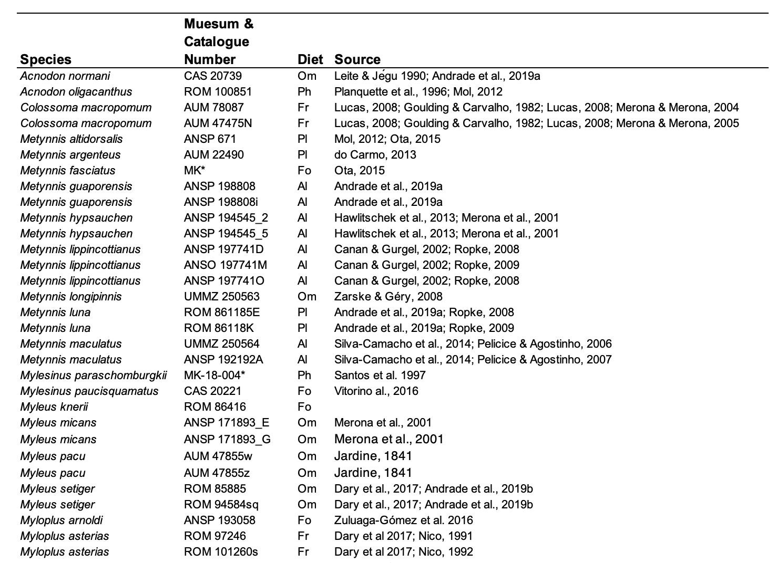

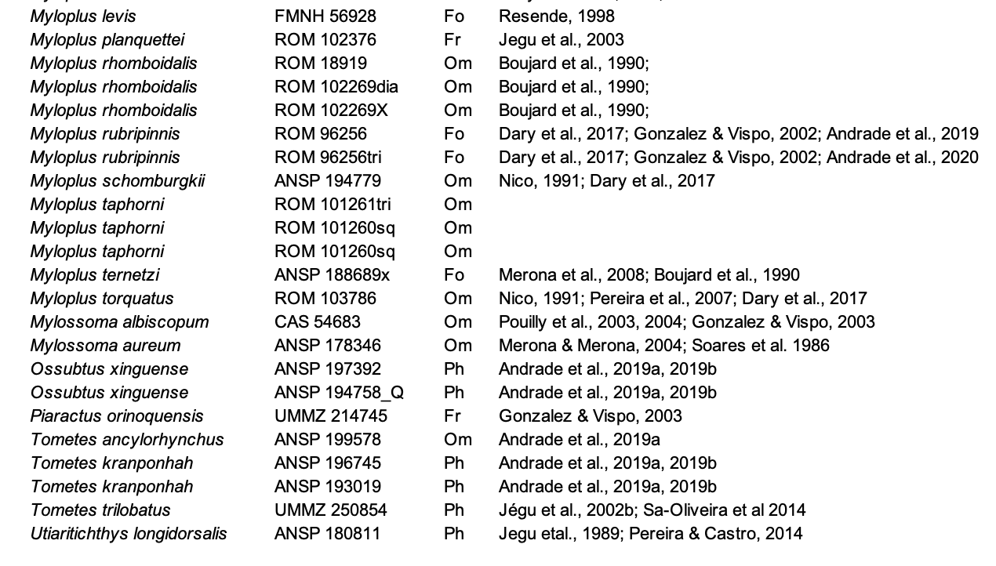

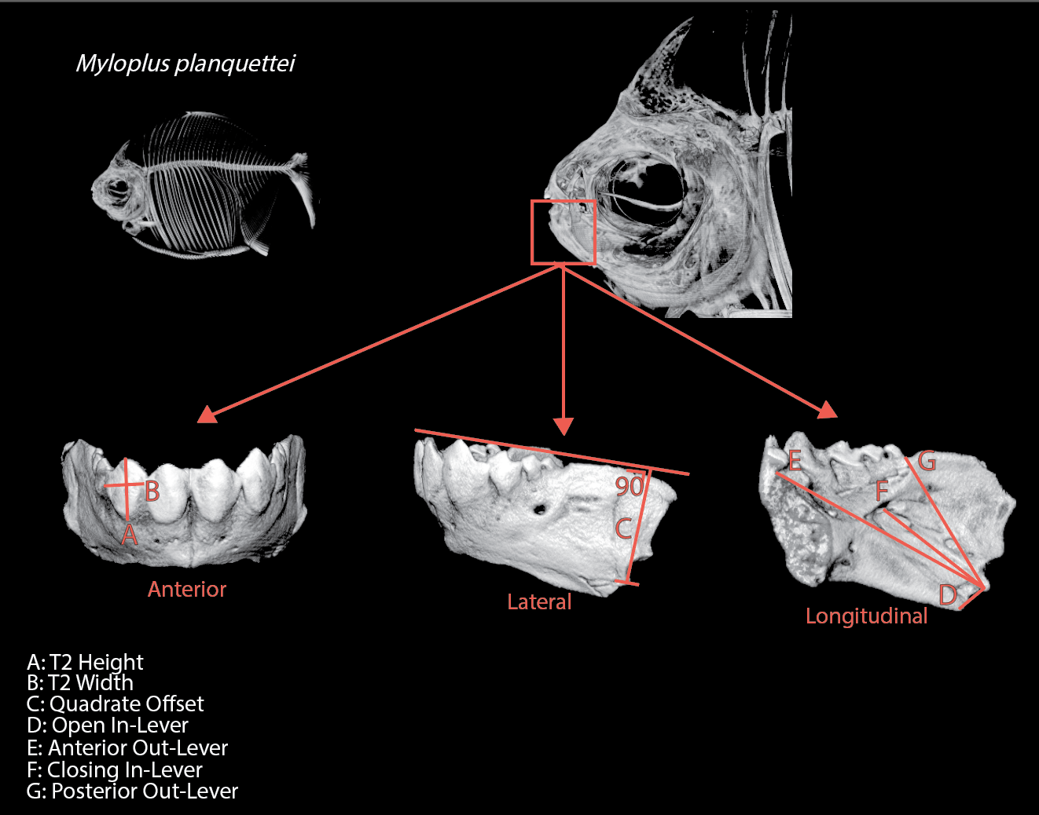

**Figure 2:** μCT scan of example specimen *Myloplus planquetti* (ROM 102376), a frugivorous pacu. Anterior, lateral, and longitudinal jaw renderings are shown below, with the digital landmarks used for the linear morphometrics specified.

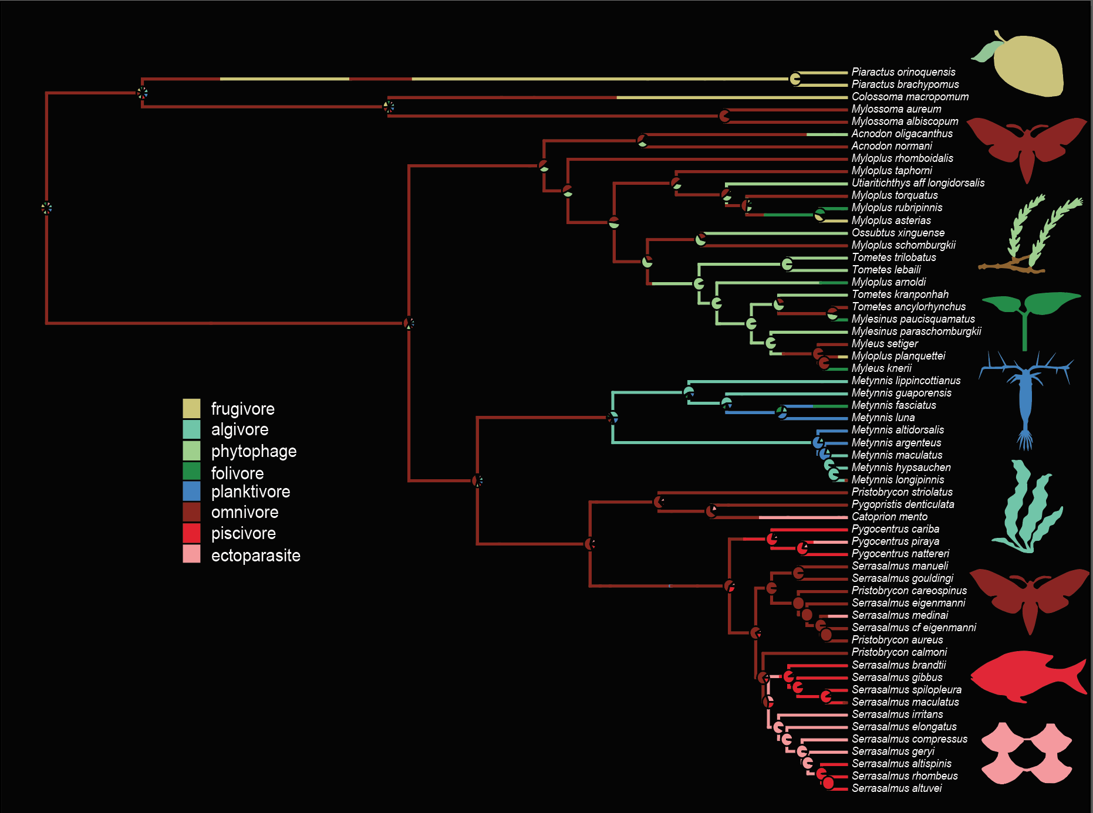

**Figure 3:** SIMMAP analyses of the Kolmann et al. (*in review*) serrasalmid phylogeny with 59 terminal species included. The species are divided into 8 possible diet groups, with different colors representing each diet guild (yellow = frugivore, teal = algivore, light green = phytophage, dark green = folivore, blue = planktivore, maroon = omnivore, red = piscivore, and pink = ectoparasite).

**Table 2**. A phyPCA was performed on the following traits corrected for size, followed by loadings for the first two principal component axes.

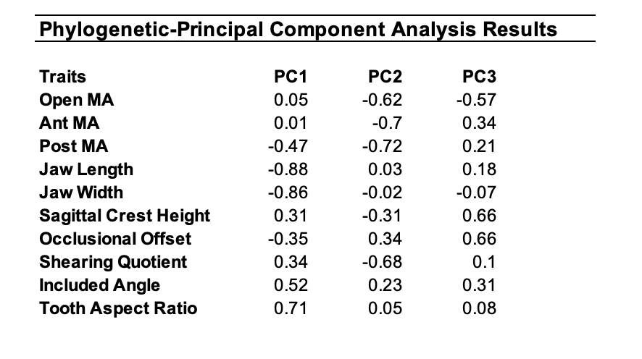

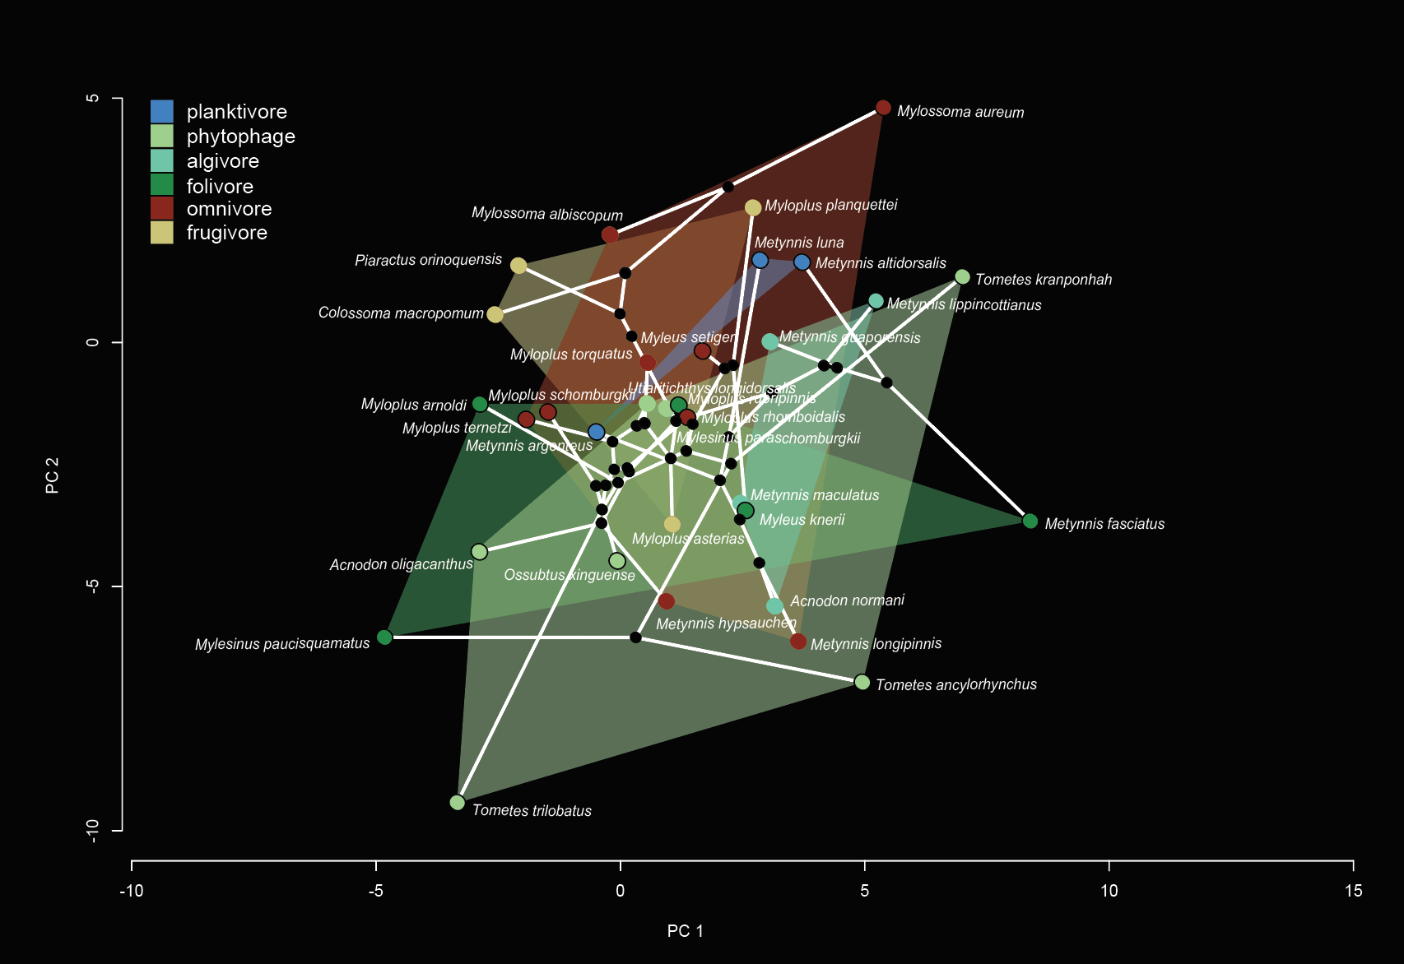

**Figure 4:** This principal component analysis represents the variation in feeding morphology among the different diet guilds of serrasalmids from this study. The different colors represent the different diet guilds (blue = planktivore, light green = phytophage, teal = algivore, dark green = folivore, maroon = omnivore, yellow = frugivore). Individual species are represented by points, and convex hulls surround each diet guild.

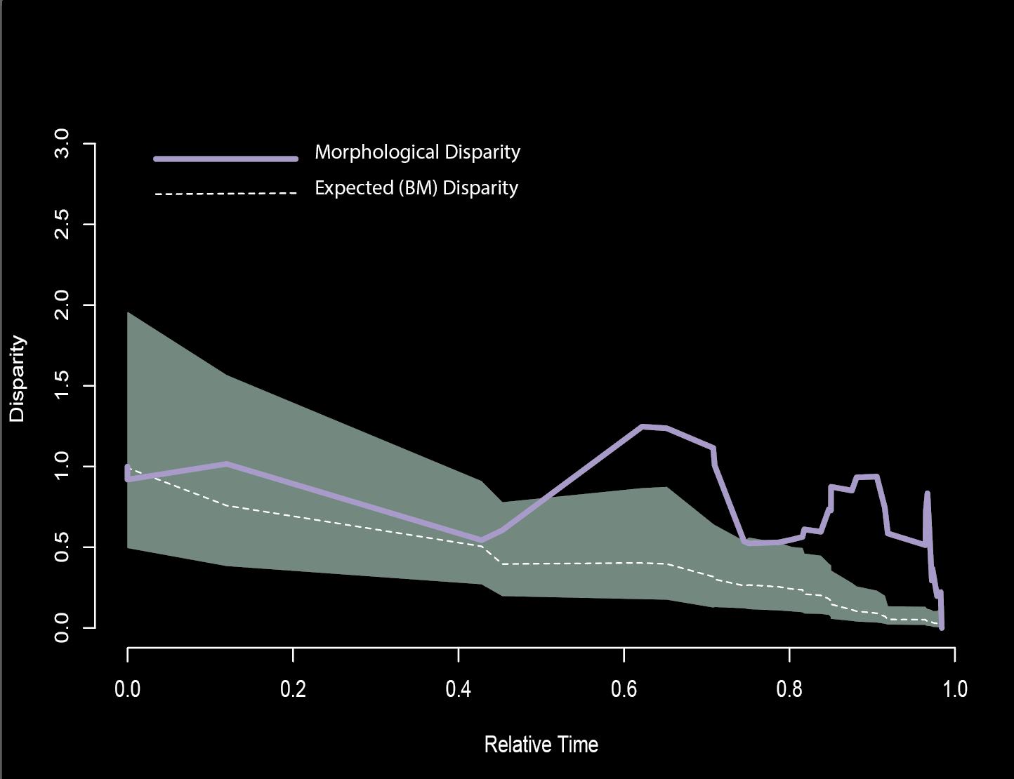

**Figure 5:** This disparity-through-time analysis depicts, with the solid purple line, the median observed average disparity of serrasalmid clades from the Kolmann et al. (*in review*) phylogeny. The mean disparity based on 1000 Brownian motion simulations is shown with the dashed line. This plot reveals a positive overall disparity, but no significant difference from the Brownian expectation.

**Table 3:** Phylogenetic rates of evolution and pairwise P-observed among the various diet guilds.

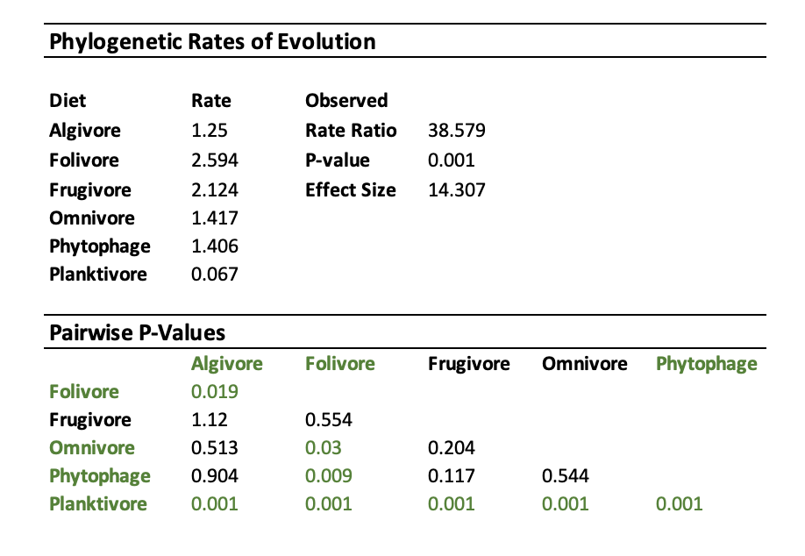

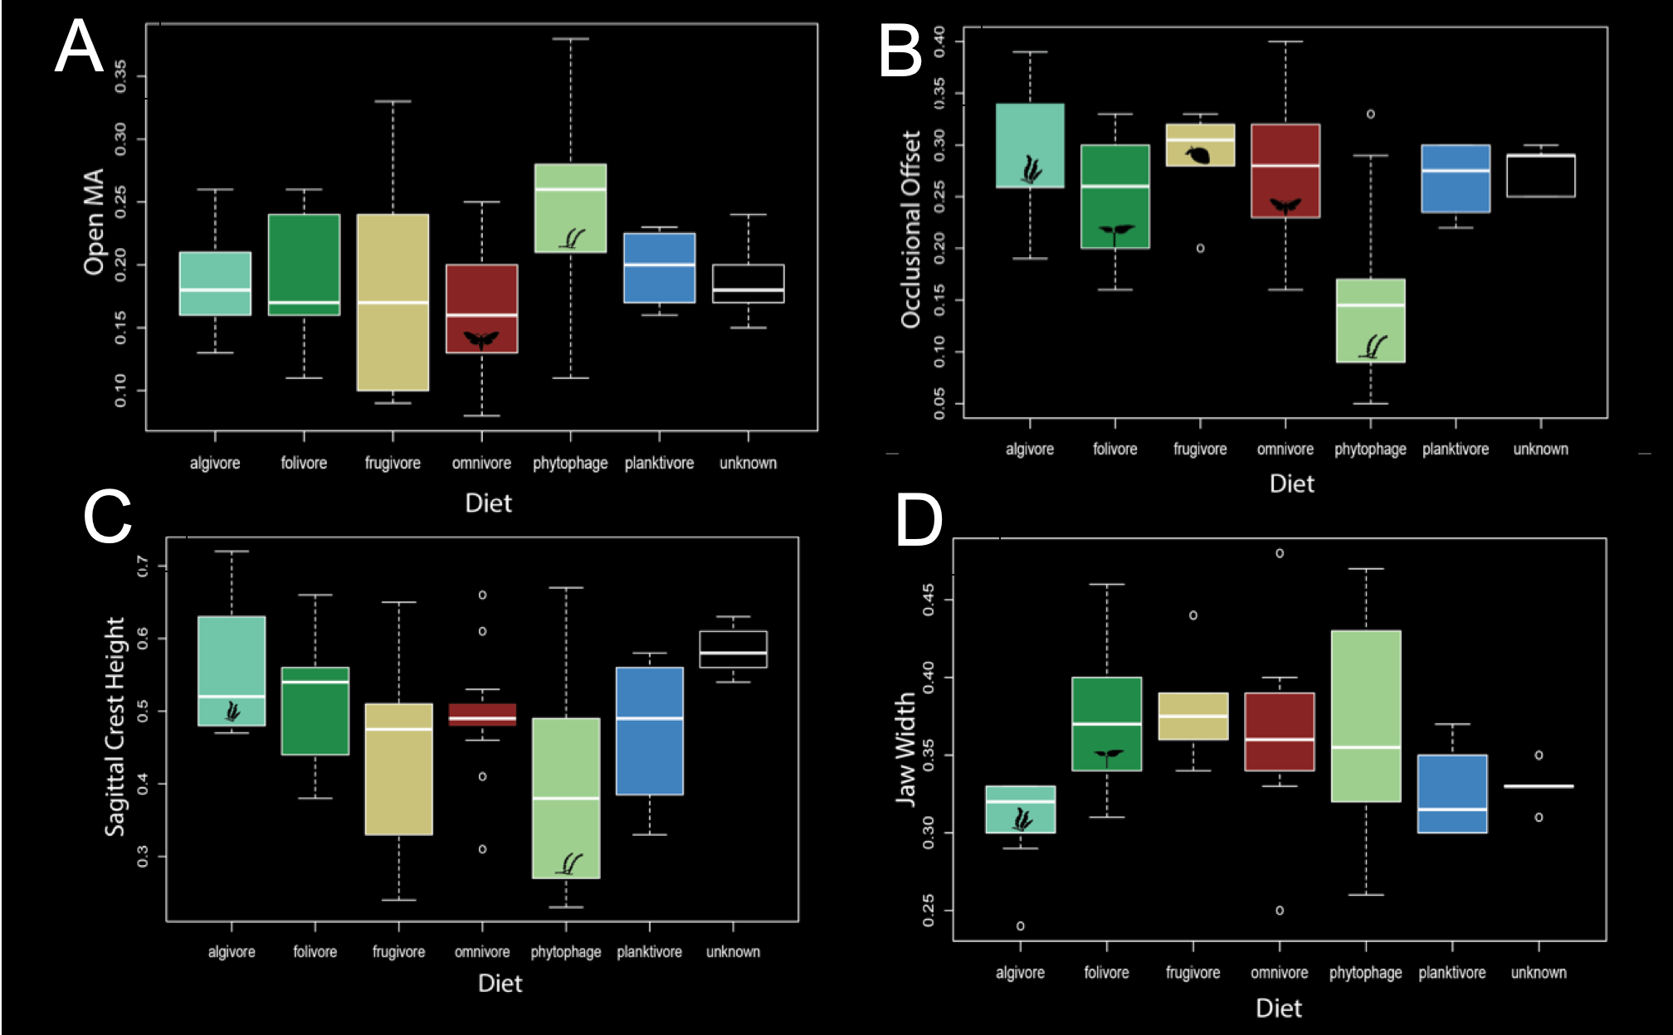

**Figure 6:** These box plots show the mean size-correlated Jaw Width (A), Occlusional Offset (B), Sagittal Crest Height (C), and Open MA(D) for each diet guild (teal = algivore, dark green = folivore, yellow = frugivore, maroon = omnivore, light green = phytophage, and blue = planktivore). The points represent single measurements that differed from the rest of the group. Jaw width (A) significantly differed between the folivores and algivores (*t*=1.906, *p*=0.059). Occlusional offset (B) was significantly different between phytophages and algivores (*t*=2.528, *p*=0.002), folivores (*t*=1.753, *p*=0.076), frugivores (*t*=2.257, *p*=0.007), and omnivores (t=2.409, p=0.005). Sagittal crest height (C) significantly differed between phytophages and algivores (*t*=2.457, *p*=0.020), and phytophages and the unknown diet group (*t*=?, *p*=0.039). Open MA (D) was significantly different between the phytophages and omnivores (*t*=2.753, *p*=0.010).

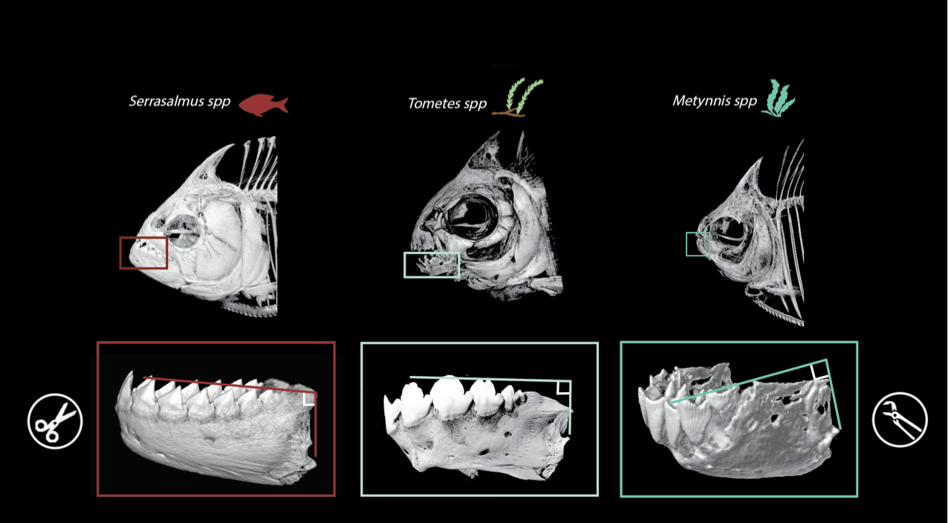

**Figure 7:** This diagram shows how occlusional offset varies among different diet groups, specifically the piscivores, phytophages, and algivores. Interestingly, the phytophages had occlusional offset values that were more similar to piranhas (*Serrasalmus spp*) than the other pacus; the piscivores and phytophages tended to have smaller occlusional offsets than the algivores, folivores, frugivores, and omnivores. As the symbols indicate, serrasalmids with lower occlusional offsets are better suited for tearing, while larger occlusional offsets are better suited for crushing.

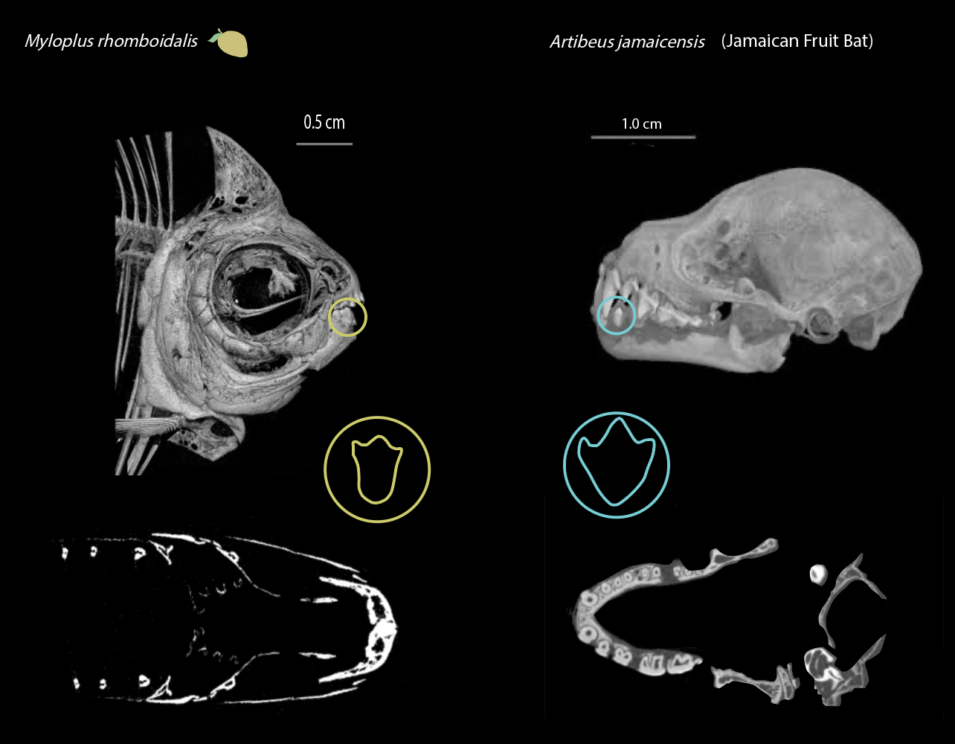

**Figure 8:** A comparison between dentitions of frugivores *Myloplus rhomboidalis* (ROM 18919) and *Artibeus jamaicensis*, a jamaican fruit bat (Dumont 2015). Tooth shape is shown (not to scale) for each animal, and both have a similar tricuspid shape and have a longer height than width, and stout, molariform rear teeth. Additionally, the CT images of the coronal plane reveal similarities in jaw width and shape, indicating convergence between the dentitions of these frugivores.

**References**

Anderson, J.T., Saldaña Rojas, J., Flecker, A.S., 2009. High-quality seed dispersal by fruit-eating fishes

in Amazonian floodplain habitats. Oecologia. 161: 279–290

Anderson, P.S., 2009. Biomechanics, functional patterns, and disparity in Late Devonian arthrodires. Paleobiology, 35(3), pp.321-342.

Andrade, M.C., Fitzgerald, D.B., Winemiller, K.O, Barbosa, P.S., Giarrizzo, T., 2019b. Trophic niche

segregation among herbivorous serrasalmids from rapids of the lower Xingu River, Brazilian

Amazon. Hydrobiologica. 829, pp.265-280.

Arbour, J.H. and López-Fernández, H., 2013. Ecological variation in South American geophagine cichlids arose during an early burst of adaptive morphological and functional evolution. Proceedings of the Royal Society B: Biological Sciences, 280(1763), p.20130849.

Bollback, J.P., 2006. SIMMAP: stochastic character mapping of discrete traits on phylogenies. BMC bioinformatics, 7(1), p.88.

Birindelli, J. L. O. & H. A. Britski, 2013. Two new species of Leporinus (Characiformes: Anostomidae)

from the Brazilian Amazon, and redescription of Leporinus striatus Kner 1858. Journal of Fish Biology 83: 1128–1160.

Buser, T.J., Finnegan, D.L., Summers, A.P. and Kolmann, M.A., 2019. Have niche, will travel. New means of linking diet and ecomorphology reveals niche conservatism in freshwater cottoid fishes. Integrative Organismal Biology, 1(1), p.obz023.

Buser, T.J., Boyd, O.F., Cortés, Á., Donatelli, C.M., Kolmann, M.A., Luparell, J.L., Pfeiffenberger, J.A., Sidlauskas, B.L. and Summers, A.P., 2020. The natural historian’s guide to the CT galaxy: step-by-step instructions for preparing and analyzing computed tomographic (CT) data using cross-platform, open access software. Integrative Organismal Biology.

Conway, K. W., N. K. Lujan, J. G. Lundberg, R. L. Mayden & D.S. Siegel, 2012. Microanatomy of the

paired-fin pads of ostariophysan fishes (Teleostei: Ostariophysi). Journal of Morphology 273:

1127–1149.

Correa, S.B. and Anderson, J.T., 2016. A non-destructive sampling protocol for field studies of seed

dispersal by fishes. Journal of Fish Biology. doi:10.1111/jfb.12963

Correa, S.B. and Winemiller, K.O., 2014. Niche partitioning among frugivorous fishes in response to fluctuating resources in the Amazonian floodplain forest. Ecology. 95(1), pp.210-224.

Correa, S.B, Winemiller, K.O., Lopez-Fernandez, H., Galetti, M., 2007. Evolutionary Perspectives on

Seed Consumption and Dispersal by Fishes. BioScience. 57(9), pp. 748-756.

Crofts, S.B., Lai, Y., Hu, Y. and Anderson, P.S., 2019. How do morphological sharpness measures relate to puncture performance in viperid snake fangs?. *Biology letters*, *15*(4), p.20180905.

Dumont, B., 2015, "Artibeus jamaicensis" (On-line), Digital Morphology. Accessed June 6,

 2020 at http://digimorph.org/specimens/Artibeus_jamaicensis/.

Egan, J.P., Gibbs, S. and Simons, A.M., 2018. Trophic niches through ontogeny in 12 species of Indo-Pacific marine Clupeoidei (herrings, sardines, and anchovies). Marine Biology, 165(10), p.153.

Fink, W. and Machado-Allison, A., 1992. Three new species of piranhas from Brazil and Venezuela. Ichth. Explor. Freshwaters, 2, pp.57-75.

Freeman, P.W., 1988. Frugivorous and animalivorous bats (Microchiroptera): dental and cranial

adaptations.Biological Journal of the Linnean Society, *33* (1988), pp. 249-272.

Goulding, M. 1980. The fishes and the forest: explorations in Amazonian natural history. University of California Press, Berkeley.

Huby, A., Lowie, A., Herrel, A., Vigouroux, R., Frederich, B., Raick, X., Kurchevski, G., Lima Godhinh,

A., Parmentier, E., 2019. Functional diversity in biters: the evolutionary morphology of the oral jaw system in pacus, piranhas and relatives (Teleostei: Serrasalmidae). Biological Journal of the Linnean Society. 127(4),722-741.

Huie, J.M., Summers, A.P. and Kolmann, M.A., 2019. Body shape separates guilds of rheophilic herbivores (Myleinae: Serrasalmidae) better than feeding morphology. Proceedings of the Academy of Natural Sciences of Philadelphia. 166(1), pp.1-15.

Kay, R.F. and Covert, H.H., 1984. Anatomy and behaviour of extinct primates. In Food acquisition and processing in primates (pp. 467-508). Springer, Boston, MA.

Kolmann, M.A., Huie, J.M., Evans, K. and Summers, A.P., 2018a. Specialized specialists and the narrow niche fallacy: a tale of scale-feeding fishes. Royal Society open science. 5(1), p.171581.

Nico, L.G. and Taphorn, D.C., 1988. Food habits of piranhas in the low llanos of Venezuela. Biotropica. 20(4), pp.311-321.

Nico, L.G. & de Morales, M., 1994. Nutrient content of piranha (Characidae, Serrasalminae) prey items. Copeia. (2): 524-528.

Pérez–Barbería, F.J. and Gordon, I.J, 2001. Relationships between oral morphology and feeding style in

the Ungulata: a phylogenetically controlled evaluation. Proc. R. Soc. Lond. B. 268 pp.1023–1032

Philbrick, C.T., and A.N. Retana. 1998. Flowering phenology, pollen flow, and seed production in

Marathrum rubrum (Podostemaceae). Aquatic Botany 62(3): 199–206.

Revell, L.J., 2012. phytools: an R package for phylogenetic comparative biology (and other things). Methods in ecology and evolution, 3(2), pp.217-223.

Sazima, I. and Machado, F.A., 1990. Underwater observations of piranhas in western Brazil. In Alternative life-history styles of fishes (pp. 17-31). Springer, Dordrecht.

Schneider, C.A., Rasband, W.S., Eliceiri, K.W. "NIH Image to ImageJ: 25 years of image analysis". Nature Methods 9, 671-675, 2012.

Sidlauskas, B., 2008. Continuous and arrested morphological diversification in sister clades of

characiform fishes: a phylomorphospace approach. The Society for the Study of Evolution.

62(12), 3135–3156.

Suzuki, R., Shimodaira, H. 2006. Pvclust: an R package for assessing the uncertainty in hierarchical clustering. Bioinformatics, 22(12), pp. 1540–1542

Young, R.L., Haselkorn, T.S. and Badyaev, A.V., 2007. Functional equivalence of morphologies enables morphological and ecological diversity. Evolution: International Journal of Organic Evolution, 61(11), pp.2480-2492.